Converting Classic Mode Graphics & Equations
Practise Document
This document allows you to practise using the new Word toolbar to convert Classic Mode graphics and equations. The example questions begin on page 2
- Close any Efofex products on your computer. Classic Mode conversion needs to open the products itself.
- Make sure you are on a Windows computer. Classic Mode conversion is not available on Mac computers.
- Push the Convert Classic Mode button.

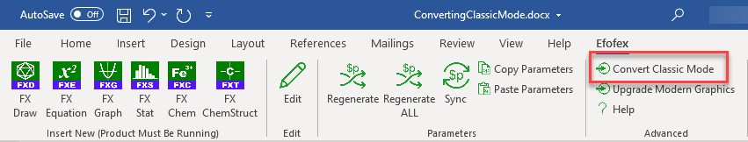

- Wait until the tool reports that conversion is complete. Please note that converting Classic Mode graphics can take some time.
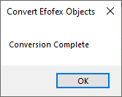
Notes:
- Converting from Classic Mode can produce unpredictable results with older graphics and equations. We strongly recommend that you run this process on a backup copy of your document.
- We have set the background colour of this document to a light green so you can see that our new system produces transparent graphics.
- Converted graphics are resized back to 100% during conversion. You will note that some graphics have increased in size due to this. These graphics should be resized in FX Draw
- Please thoroughly check the output produced by the conversion tool. You may need to adjust some graphics, particularly if the original graphics were old.

Geometric Proof Exercises

1. Given and bisect each other at E, prove

2. Given , prove

3. Given and prove

4. Given and prove

5. Given prove

6. Given and prove

7. Given circle with centre H and prove

8. Given prove

9. Given prove

10. Give D, B and F are collinear and prove that the sum of the three angles in is 180°

Geometric Proof Exercise Solutions

1.

2.

3.

4.

5.
6.

7.

8.

9.

10.

